**Preliminary definitions:**

-Bucket-bridging: a signalling propagation process where the signal is passed unidirectionally by neighboring agents.

-Saltatoric propagation: signal propagation by ‘jumping’ of the signal, as action potentials in neurons jump between disconnected conductive regions, speeding up propagation.

**Results:**

Bees are 6 mm in width.

Abdominal flipping (shimmering signal) lasts ~67.16 ms.

Bucket-bridging: Measuring information transfer between adjacent bees around 15.94 mm apart, information transfer was transferred at 39.16 ms (0.5085 m/s). Considering two bees at a distance of about 43.32 mm (with more bees between them), the speed was actually measured at 0.317 m/s, likely reflecting lowered speed because the path connecting a few bees wasn’t perfectly straight.

Saltatoric propagation: bees ~80 mm ahead of the front activated 30-50 ms before other bees in their near neighborhood (40 mm radius circle). Example: front was moving at 0.239 m/s and within 16.67 ms of activation, the wave progressed 160 mm for 0.96 m/s.

Each shimmering wave lasts ~0.8 s and reaches its highest number of member agents at ~0.2 s. Velocity at the beginning of the wave was 0.367 metres per second (thus mostly bucket bridging) and progressed to 0.514 metres per second at climax (thus partly saltatoric).

Average number of shimmering neighbors in the past (or future) # of frames, pre and post shimmering (i.e. a point at +5 ff, 3 neighbors implies that within five frames of shimmering, 3 neighbors have shimmered) for 1,2) (status I)bees that shimmered and triggered their neighbors after shimmering, 3) (status II) bees that shimmered and didn’t trigger their neighbors 4) (status III) bees that had no shimmering neighbors when triggered:

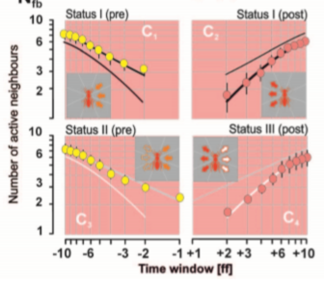

Status I bees are about 72%, status II are 13% and status III are 15%.

Relative number of status II bees with a certain number of shimmering neighbors within 10 frames before shimmering. Similar with status III but for 10 frames after shimmering.

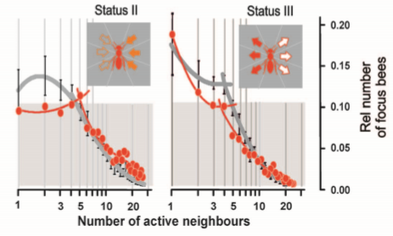

The 40 mm neighborhood of each bee was cut up into 8 sections as showed in A. The number of shimmering agents in each of these sections were measured in this neighborhood before (yellow) and after (red) shimmering of the focus bee and plotted here. C and D are for status I bees, E is for status II and F for III.

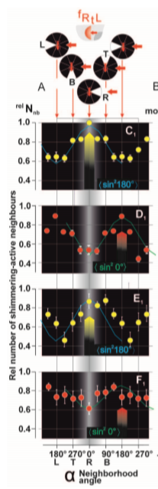

**Ideas:**

Start with only status I and II agents and a single nucleation event on a matrix. I’ll use the propagation and sustain times reported above, assume status II agents are dispersed randomly and investigate wave speed as a function of their percentage. I’ll also test deciding to be II as a function of % of neighbors. I’ll see if I can recuperate the active neighbor data and % status II data shown above.

I will change the valency and connectivity of the bees and see how wave speed and neighbors are affected.

I will add in status III bees as per the data above measuring wave speed by some parameters I choose.